תרגיל כיתה -1 למידת מכונה

שם הסטודנט סמיר זהר 206015125

שאלה מס 1

* עומק העץ הוא 5
* ה *accuracy הוא 0.96*
* ה *precision הוא 0.964*

2.

|  |  |  |  |  |
| --- | --- | --- | --- | --- |
| Recall | F1_score | precision | Accuracy | Depth tree |
| 0.666 | 0.555 | 0.5 | 0.667 | 1 |
| 0.953 | 0.945 | 0.96 | 0.953 | 2 |
| 0.96 | 0.959 | 0.967 | 0.96 | 3 |
| 0.953 | 0.952 | 0.959 | 0.953 | 4 |
| 0.96 | 0.959 | 0.959 | 0.96 | 5 |
| 0.953 | 0.959 | 0.964 | 0.96 | 6 |
| 0.953 | 0.952 | 0.964 | 0.953 | 7 |
| 0.96 | 0.952 | 0.964 | 0.96 | 8 |
| 0.96 | 0.952 | 0.959 | 0.953 | 9 |
| 0.96 | 0.959 | 0.964 | 0.953 | 10 |

3. [[ 1 666 500 666 500]

[ 2 946 960 953 960]

[ 3 960 966 960 966]

[ 4 960 964 960 964]

[ 5 953 964 960 964]

[ 6 960 958 953 958]

[ 7 960 964 953 964]

[ 8 953 964 960 964]

[ 9 960 958 953 958]

[ 10 953 958 953 958]

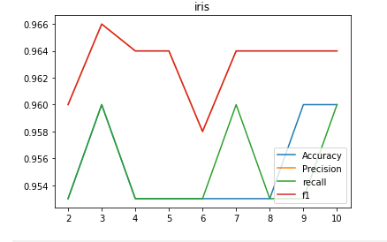

4.

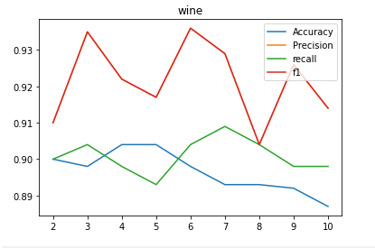

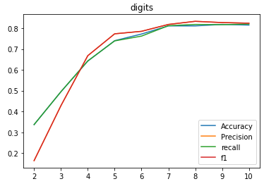5.